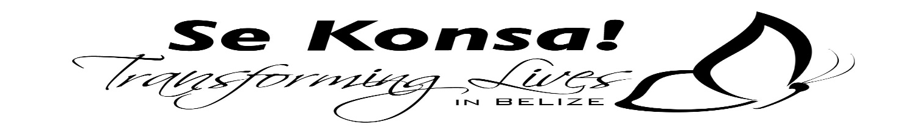
501 -673-5575
ACCIDENT WAIVER & RELEASE OF LIABILITY FORM
I hereby assume all the risks of participating in any/all activities associated to Camp Se Konsa! including by way of example and not limitation, any risks that may arise from negligence or carelessness on the part of the persons entities being released, from dangerous or defective equipment or property owned, maintained, or controlled by them or because of their possible liability without fault.
I certify that there are no health-related reasons or problems which preclude my participation in this activity.
I acknowledge that this Accident Waiver and Release of Liability Form will be used by the event holders, sponsors, participants, and organizers of the activity, I hereby take action for myself, my executors, administrators, heirs, next of kin, successors, and assign as follows:
- I WAIVE, RELEASE, AND DISCHARGE from any and all liability, including but not limited to liability arising from the negligence or fault of the entities, or persons released for my death, disability, personal injury, property damage, property theft, or actions of any kind which may hereafter occur to me including my traveling to and from this activity. THE FOLLOWING ENITITIES OR PERSONS: Se Konsa! and/or their directors, officers, employees, volunteers, representatives, and agents, and the activity holders, sponsors:

- INDEMNIFY, HOLD HARMLESS, AND PROMISE NOT TO SUE the entities or person mentioned in this paragraph from any and all liabilities or claims made as a result of participation in this activity, whether caused by the negligence of release or otherwise.

I acknowledge that this activity may involve a test of person’s physical and mental limits and carries with it the potential for death, serious injury, and property loss. The risks include, but are not limited to those caused by terrain, facilities, temperature, weather, condition of the participant’s equipment, vehicular, traffic, lack of hydration, and actions of other people including, but not limited to participants but are also present for volunteers.

I hereby consent to receive medical treatment which may be deemed advisable in the event of injury, accident, and/or illness during this activity.
PHOTOGRAPHED/VIDEO PLEASE INTIAL THE LINE BEFORE THE AREA THAT YOUR AGREEING TO
_______ I agree to allow my photo, video, or film likeness to be used for any legitimate purpose by the activity holders, producers, sponsors, organizers and assigns.
_______ I Do NOT agree to allow my photo, video, or film likeness to be used for any legitimate purpose by the activity holders, producers, sponsors, organizers and assigns
I CERTIFY THAT I HAVE READ THIS DOCUMENT AND FULLY UNDERSTAND ITS CONTENT, I AM AWARE THAT THIS IS A RELEASE OF LIABILITY AND A CONTRACT AND I SIGN IT OF MY OWN FREE WILL.
__________________________________________________ ________________
Participants Name (please print legibly) age

____________________________________________________ _________________
Participants Signature Date

____________________________________________________ __________________
Parent/Guardian Signature Date

_______________________________________
Contact number

Emergency Contact Person __________________________________ Relationship__________
Telephone # ______________________________

